**Jennifer Tjia CMST 386 7380**

**Client and Topic**

This website will serve as a personal portfolio to showcase my skills in website design, graphic design, and creative projects. It will emphasize completed works, provide insight into my creative process, and function as a professional hub for attracting potential clients and employers. The portfolio will represent my unique design style, technical abilities, and creative problem-solving skills, setting me apart in the competitive market. This project aims to establish my online presence as a designer while acting as a dynamic tool for career growth and client engagement.

**Development Process and Engagement**

Since this is a personal portfolio website, I will rely on thorough research to inform its development. I will analyze successful portfolio websites to identify best practices, trends, and engaging design features. Additionally, I will study competitor portfolios to determine what elements resonate with audiences in my target demographic. Content will be carefully crafted to highlight my strengths and tailored to meet the expectations of potential clients, ensuring my professional branding aligns with audience needs.

**Testing**

To ensure the website is functional and error-free before launch, I will conduct rigorous testing. This will include usability tests with friends and family to evaluate navigation, responsiveness, and overall user experience. Compatibility testing will be performed on popular browsers, including Google Chrome, Mozilla Firefox, Microsoft Edge, and Safari, to guarantee consistent functionality. Mobile testing on various devices will verify responsiveness. Additionally, I will use tools such as Google Lighthouse and BrowserStack to test for accessibility, performance, and SEO compliance. All links, images, and navigation elements will be verified for accuracy and functionality.

* **Home**: Does the page provide a professional yet welcoming introduction to who I am as a designer? Does it effectively showcase my style and key highlights of my work? Are there design or layout changes that could make the Home page more visually appealing or user-friendly?
* **About Me**: Does the content provide a clear and relatable picture of my background, skills, and personality? Does it create a connection with potential clients? Are there ways to make this page more engaging, such as adding additional personal anecdotes or professional highlights?
* **Projects**: Is the organization of projects into subcategories (Web Design, Graphic Design) intuitive? Do the project descriptions provide enough detail to explain the challenges, solutions, and tools used? Are the images of each project clear and high quality? Would visitors find these projects inspiring and credible?
* **Blog**: Are the blog subcategories (Games, Everyday, Design Content) relevant and appealing to the audience? Is the writing style engaging and easy to read? Are the topics interesting enough to encourage visitors to return to the site? What additional topics might be useful to include?
* **Contact**: Is all the contact information (email, phone, and social media links) easy to find and clear? Are there suggestions for additional ways to connect with me or present the information more effectively?

**Description**

This portfolio will represent my professional design work, focusing on website, illustrations, and graphic design projects. Its primary goal is to attract new clients, showcase my capabilities, and serve as a professional branding tool.

The website’s purpose is to establish my credibility as a designer, provide a platform for showcasing my projects, and act as a point of contact for potential clients. It will also serve as a space to share insights, articles, and tutorials about my design process.

The target audience for my portfolio website includes small business owners, creative professionals, and HR professionals or recruiters, chosen for their alignment with the website's purpose of showcasing my skills and attracting opportunities. Small business owners often need professional web and graphic design services to enhance their branding, making them a key audience to convert into clients. Creative professionals seek collaborative opportunities and inspiration, valuing visually dynamic and innovative designs that align with their artistic visions. HR professionals and recruiters evaluate portfolios to assess candidates for creative roles, requiring a well-organized and professional site to efficiently review my qualifications. By addressing the unique needs of these audiences, the portfolio will effectively demonstrate my expertise, build credibility, and create opportunities for collaborations and job prospects.

**Persona 1: The Small Business Owner**

* **Name**: Sarah Thompson
* **Age**: 38
* **Occupation**: Owner of a local bakery
* **Education**: Bachelor’s degree in Business Management
* **Location**: Suburban area
* **Income Level**: Middle-class
* **Tech Skills**: Moderate; uses technology primarily for business purposes.
* **Goals**:
  + Find a professional designer to create an engaging website for her bakery.
  + Showcase her products online with visually appealing layouts.
  + Attract new customers and establish an online presence.
* **Preferred Access**: Primarily desktop during business hours, but occasionally browses via mobile.

**Persona 2: The Creative Professional**

* **Name**: Alex Rodriguez
* **Age**: 29
* **Occupation**: Freelance photographer
* **Education**: Bachelor’s degree in Fine Arts
* **Location**: Urban area
* **Income Level**: Moderate; income varies by project.
* **Tech Skills**: High; uses advanced photo editing tools and is familiar with design trends.
* **Goals**:
  + Collaborate with a designer to create branding for his photography business.
  + Gain inspiration for his own portfolio website.
  + Learn from blog posts or tutorials about design practices.
* **Preferred Access**: Both mobile and desktop; often browses during commutes or between shoots.

**Persona 3: The HR Professional**

* **Name**: Michael Patel
* **Age**: 45
* **Occupation**: Human Resources Manager at a mid-sized tech company
* **Education**: MBA in Human Resources
* **Location**: Urban area
* **Income Level**: Upper-middle-class
* **Tech Skills**: Moderate; comfortable with professional tools but not deeply technical.
* **Goals**:
  + Evaluate potential hires for the company’s creative team.
  + Review portfolio websites to assess candidates' skills and versatility.
  + Find a designer who can potentially work on corporate branding materials.
* **Preferred Access**: Desktop at work during business hours.

The target audience’s preferences and needs will directly influence the website’s design. For small business owners, the website must convey professionalism and trustworthiness, using clean layouts, clear navigation, and visually engaging project displays. Creative professionals, such as photographers and designers, will expect dynamic, visually appealing designs that reflect my creativity and ability to push boundaries. HR professionals, on the other hand, prioritize efficiency and organization, so the site must enable quick access to relevant information, such as portfolio pieces and contact details. To accommodate all audiences, the site will be mobile-responsive, ensuring seamless browsing on any device. The design will also incorporate accessibility standards to ensure usability for all visitors, including those with disabilities.

The website’s content will consist of both original and sourced materials. Original content will include detailed case studies, project galleries, blog posts about design techniques, and unique visual branding elements. Each project in the portfolio will include custom-written descriptions highlighting the challenges, solutions, and tools used. Blog posts will offer insights into my creative process and trends in the design industry, further establishing credibility and engagement with visitors. Sourced content, such as stock images or design inspirations, will be carefully credited to maintain professionalism and compliance. Together, the combination of unique and sourced content will create a rich, informative experience for the target audience.

To keep the website dynamic and engaging, content will be updated regularly. The portfolio section will be refreshed monthly as new projects are completed and added. Blog posts will be published bi-weekly to maintain relevance and provide ongoing value to the audience. Testimonials and additional client feedback will be incorporated quarterly to reflect current collaborations and successes. Routine updates, such as optimizing images and refining SEO strategies, will occur monthly. By maintaining this schedule, the website will remain relevant, engaging, and reflective of my professional growth.

**Growth and Maintenance**

The website will grow by continuously adding new projects and blog content to keep it relevant and engaging. To facilitate maintenance, I will use modular design elements and a content management system to simplify updates. Maintenance tasks will include:

* Daily: Monitoring site performance and uptime.
* Weekly: Checking links, updating plugins, and reviewing analytics.
* Monthly: Adding new content, optimizing images, and refreshing SEO strategies.  
  As the site evolves, I may add new sections, such as a resources page or interactive design tools, to increase value for visitors.

**Organization**

Home page wireframe

Interior page wireframe

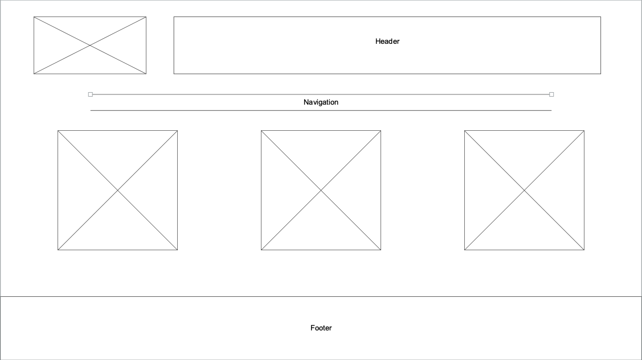

The website will be meticulously organized to ensure a seamless and intuitive user experience. Content will be divided into clear categories and subcategories, making it easy for visitors to navigate and locate the information they need. The primary structure of the site will include the following main sections: Home, About Me, Projects, Contact, and Blog.

The Home page will serve as an introduction to the site, offering a brief overview of who I am, my professional focus, and key highlights of my work.

The Projects section will showcase my portfolio and be further divided into two subcategories: Web Design and Graphic Design. These subtopics will organize the projects based on their type, making it easier for users with specific interests to find relevant work. Each project page will include high-quality images, detailed descriptions of the work, tools used, and any challenges overcome during the process.

The Blog section will be divided into three subcategories to cater to different audience interests: Games, Everyday, and Design Content. The Games category will feature posts about my experiences and insights related to gaming, while Everyday will include more casual, personal content to connect with readers on a relatable level. The Design Content category will focus on professional insights, tutorials, and reflections on industry trends.

The About Me page will offer visitors a deeper understanding of my background, expertise, and journey as a designer. This section will also include a summary of my skills, certifications, and interests, helping to build a personal connection with potential clients or collaborators.

The Contact page will provide multiple ways for visitors to get in touch with me, including my email address, phone number, and links to social media profiles. This ensures clear, direct communication channels without relying on forms or gated content.

To make navigation as efficient as possible, a sticky top menu will be implemented, allowing users to access any section of the website regardless of where they are on a page. Each section will have a consistent layout to maintain familiarity throughout the site. Additionally, a **footer** will include quick links to important sections, legal information, and a brief tagline about my services.

Overall, the website’s organization will prioritize clarity, usability, and efficiency, ensuring an enjoyable browsing experience for all visitors.

**Security**

This website will not include e-commerce or password-protected content because it is a public-facing portfolio. User accounts are unnecessary as the site’s focus is on showcasing work and facilitating client outreach. To ensure security, I will implement an SSL certificate, use secure coding practices, and keep all plugins and libraries up to date. I will also use secure file permissions and regularly monitor the website for vulnerabilities.

**Web Hosting**

Host Selection Criteria:

* Reliable uptime with minimal downtime.
* Support for PHP, MySQL, and SSL.
* Scalable options for future growth.
* Affordable pricing with responsive customer support.

Technologies Needed: SSL for security and PHP for dynamic display of information if needed.

The website will primarily rely on HTML5, CSS3, and JavaScript for its functionality and design. These languages are essential for creating a modern, responsive, and visually engaging website:

* HTML5: This will provide the structure and semantic elements necessary to create the web pages, ensuring compatibility across devices and browsers. Its features also enhance accessibility and SEO, critical for attracting and engaging users.
* CSS3: CSS will be used to style the website, allowing customization of fonts, colors, layouts, and animations. CSS3's advanced features, like media queries, enable responsive design, ensuring the site works seamlessly on desktops, tablets, and mobile devices.
* JavaScript: JavaScript will add interactivity and dynamic content to the website. For example, it can enable image lightboxes, portfolio filters, or other interactive elements that enhance user experience.

While these three languages form the foundation, the website may also benefit from support for PHP and MySQL if server-side scripting or database functionalities are needed in the future. For example:

* PHP: This scripting language is commonly used for dynamic content generation and can be useful if I decide to add a blog or client management features.
* MySQL: While not currently required, database support could be useful for storing and managing project details or blog content down the line.

Domain Name: I will register jennifertjia.com to create a professional and memorable online presence. The name directly reflects my own identity and aligns with personal branding goals.

**Marketing**

The website will be marketed through social media platforms such as LinkedIn, Twitter, and Instagram. I will also join design forums and online communities to share my work. SEO strategies will include optimizing page titles, meta descriptions, ALT text for images, and keyword usage. A blog section with relevant topics will drive organic traffic and improve search engine rankings over time. Additionally, I will submit the website to Google Search Console and other webmaster tools to enhance visibility.